

**Mitsubishi PS 3 2 Ton**

**Rs. 121,499/-**

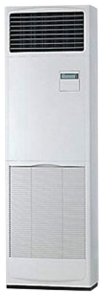

**Product Features**

* Multi- Mode for Installation
* Free Setting of Air Discharge Duct
* dry function
* wide voltage
* active PFC technology

**Specification**

**Type** Floor Standing AC

**Cooling (Btu/h)** 52000

**Voltage (V)** 220-240

**Power Input (W)** 4100

**EER (Btu/W-h-W/W)** 7.2-4.35